June 29, 2026

Patient Empowerment Guidebook Promotion Campaign Proposal

Campaign Overview
Purpose
This document outlines a proposed targeted multi-channel amplification strategy to launch and promote the LAN Patient Empowerment Guidebook, with the goal of driving awareness, engagement, and adoption among key stakeholder audiences. This Guidebook is a practical resource developed by the Patient Empowerment Workgroup to help providers, ACOs, health plans, employers, and CBOs design and scale adoption strategies.
The campaign is organized into three phases (preparation and building awareness, deepening engagement, and expanding reach) to enable the LAN Operator Team to promote the Guidebook through approved channels such as the LAN website, listserv, and LinkedIn, while also exploring additional channels including podcasts, press outreach, a hybrid event, and broader member network activation.
We are seeking your approval to proceed with implementation ahead of the July 28, 2026, target launch date.
Table 1 below summarizes the campaign goals, target audiences, and proposed campaign window.
Table 1. Campaign Overview
Goals | The LAN Operator Team aims to:  - Increase awareness of this Guidebook across the health care ecosystem  - Position the LAN as a definitive voice on patient empowerment  - Encourage stakeholders to explore and apply Guidebook strategies  - Deepen and sustain engagement across the LAN member network beyond launch
Primary Audiences | - Providers (including ACOs)  - Health Plans/Payers  - Employers  - Community-Based Organizations (CBOs)  - Patients, patient advocates, and caregivers
Campaign Window | Launch: July 28, 2026, + three-month amplification campaign (July 2026 – September 2026)

Campaign Strategy
Through a targeted, multi-channel amplification strategy, the LAN Operator Team aims to:
- Build awareness around the Guidebook for general audiences while highlighting its value for specific audiences/stakeholders.
- Deepen engagement and thorough understanding across LAN partners and industry organizations that results in the adoption of the Guidebook’s concepts and recommendations.
- Expand the reach and conversation around patient empowerment within the health care transformation ecosystem.
Table 2 summarizes the high-level strategy approach the LAN Operator Team will use to develop a comprehensive communications campaign to amplify the Guidebook. To read more about the Guidebook itself, please visit the appendix.
Table 2. Campaign Strategy
 | Goal | Communications Approach | Success Indicators
Strategy 0: Activate LAN Member Network | Prepare and share promotional campaign materials with LAN members as the foundation for the implementation and success of the subsequent amplification strategies. | Member Network Mobilization to create awareness and encourage member promotion, via:  - Comms kits  - Email and workgroup meeting outreach  - Shareable one-pager/slide | - Number of member shares/amplifications on LinkedIn  - Engagement with member posts  - Additional instances of member amplification (known email shares/forwards, etc.)
Strategy 1: Build Awareness | Prepare and distribute campaign materials to build broad awareness of the Guidebook, including where to access it and the value it provides to current LAN members and engaged audiences. | Fully leverage LAN-owned channels to drive awareness of resource.  Key channels include:  - LAN Listserv  - LAN Website  - Member Network Mobilization  - Social Media (LinkedIn) | - Resource webpage users and engagement  - Resource downloads  - Email engagement metrics  - LinkedIn engagement on LAN posts, including reposts  - Resource page visits  - Resource downloads
Strategy 2: Deepen Engagement Among Industry Practitioners | Encourage core stakeholders in the industry (e.g., practitioners actively working on VBC as/in providers, plans, CBOs, etc.), to move beyond awareness by helping them interact with, discuss, and contextualize the Guidebook. | Hold a featured event showcasing perspectives from Workgroup members and stakeholders who contributed to the resource  Key channels include:  - LAN-Sponsored Events (e.g., virtual, hybrid) | - Event registrations  - Event attendance  - Event engagement (e.g., Q&A and raise hand feature, poll responses, event chat, etc.)  - Event recap engagement  - Follow-up website traffic
Strategy 3: Expand Reach | Expand awareness of the Guidebook beyond LAN’s existing audience members and contribute to broader industry conversations about patient empowerment. | Target audiences through health care trade publications and industry media outlets.  Key channels include:  - Podcasts  - Press Outreach | - Earned media placements  - Podcast appearances and reach  - Referral traffic  - External audience engagement  - Independent posting by LAN stakeholders
Campaign Close-Out | Wrap up the campaign by completing performance tracking and post-campaign summary. | N/A | - Collect metrics from all available channels  - Evaluate performance and prepare summary

Details by Strategy & Channel
For a more detailed view of the channels proposed in Table 2, see the strategies and Tables (3–9) below.

Strategy 0: Activate LAN Member Network
The LAN Operator team aims to kick off the promotional campaign by activating the LAN member network as the foundation for the implementation and success of the subsequent amplification strategies.

Member Network Mobilization
Table 3 outlines the LAN Operator Team's recommendations for the effective mobilization of the LAN member network to promote the Guidebook.
Table 3. Member Network Mobilization
Member Network Mobilization
Description | Use tailored calls to action across the member network to expand reach and ensure high-value content reaches the right stakeholders, reinforcing the LAN’s leadership on patient empowerment.  Format  Primary channels are email, meeting slides, and LinkedIn amplification. Messaging should be tailored by audience: Co-Chairs receive a formal amplification request with suggested language, while Workgroup members receive a comms kit for self-directed sharing.  Identified Audiences  - PE Workgroup Co-Chairs and members  - Executive Forum Co-Chairs and members  - Broader LAN member network, including health plans, providers/ACOs, employers, community-based organizations, and patient advocates
Timing &  Cadence | Monthly touchpoints during the three-month campaign sprint, as outlined in the strategic communications plan Campaign Schedule. Will be deployed in strategies 0 and 1.  - Month 1 (July, launch week): Share PE Workgroup comms kits and a Co-Chair amplification blurb alongside the resource launch and July email blast  - Month 2 (August): Send a follow-up to PE Workgroup members and introduce the resource at the 8/20 Executive Forum meeting  - Month 3 (September): Send a final outreach after the roundtable debrief to promote the Guidebook and to encourage adoption
Supporting Materials | - PE Workgroup member comms kit with social copy, email blurb, and key messages  - Co-Chair amplification blurb for LinkedIn and email outreach  - EF member outreach email template  - Workgroup meeting slide with resource summary and sharing instructions  - One-page Guidebook overview PDF for forwarding

Strategy 1: Build Awareness
The LAN Operator team aims to implement Strategy 1 through previously approved promotional cross-channel activities (e.g., LAN listserv, website, and social media) to officially launch the resource publicly, as soon as it is ready for release.

LAN Listserv
Table 4 outlines the LAN Operator Team's recommendations for effective listserv promotion of the Guidebook.
Table 4. LAN Listserv
LAN Listserv
Timing &  Cadence | Share embargoed Press Release, feature in a monthly spotlight, and in a post-launch email.
Description | Share the press release through the LAN listserv, feature as a spotlight in the July monthly email blast and highlight in a post-launch follow-up email to promote the Guidebook. This is an effective way to extend reach through an owned channel, reinforce awareness after launch, and repurpose and share LAN content about the Guidebook from podcasts, LAN-hosted events, and external events.  The listserv provides a direct, owned channel to reach the LAN’s subscriber base of ~10,000 members with key messaging about the Guidebook.  - A launch-day press release ensures high-visibility stakeholders, such as payers, providers, and workgroup members, receive official notice through a trusted source  - A post-launch follow-up sustains momentum, reinforces key messages, and drives continued traffic to the Guidebook landing page, deepening engagement beyond the initial launch window
Proposed Output(s) & Supporting Materials | - Draft copy for:  - Press release  - Main feature section of the monthly newsletter  - Post-launch follow-up email

LAN Website
Table 5 outlines the LAN Operator Team's recommendations for a comprehensive website launch of the Guidebook.
Table 5. Website
Website
Timing &  Cadence | Launch webpages two days before resource release. Will be deployed in strategies 0 and 1.
Description | A coordinated web launch will position the LAN as the Guidebook’s primary digital home, creating a clear path for users to discover, access, and share the resource.  A dedicated landing page, modeled on pervious LAN resources, will provide a more engaging entry point and reinforce the LAN’s leadership on patient-centered payment transformation.
Proposed Output(s) & Supporting Materials | - Homepage: add banner  - Guidebook Resource Landing Page: release interactive landing page  - Resource Library: add PDF of Guidebook to library  - PE Workgroup: update with link to PDF and landing page  Additionally, on the day of the launch we will post the press release to the News section of the website.

Social Media
Table 6 outlines the LAN Operator Team's recommendations for effective LinkedIn promotion of the Guidebook.
Table 6. Social Media
Social Media
LinkedIn
Timing &  Cadence | - Pre-launch: 2–3 posts, 8–10 days before launch  - Post-launch: 1–2 posts per month for the remainder of the campaign, over approximately 10 weeks
Description | Use LinkedIn to reach the primary audience with concise, informed messaging that promotes the Patient Empowerment Workgroup and the Guidebook.  The social strategy will include two mini-campaigns:  - a pre-launch “coming soon” series to build awareness and anticipation  - a post-launch series to sustain visibility after release  Note: Content can also be repurposed from podcast features, earned media, LAN-sponsored events, and external events to extend reach.  Targeted social messaging will build interest, shape the narrative, and create momentum ahead of launch and throughout follow-up communications. Sustained post-launch posting will help maintain engagement and reinforce LAN’s role as a trusted source for patient empowerment resources.
Proposed Output(s) & Supporting Materials | - Pre-launch, launch, and post-launch copy  - Social graphics, including carousel assets and supporting language  - Video testimonials from 2–4 PE WG members

Strategy 2: Deepen Engagement Among Industry Practitioners
The LAN Operator team aims to implement Strategy 2 through LAN-hosted events.

LAN-Sponsored Events
Table 7 outlines the LAN Operator Team's recommendations for effective execution of a LAN-sponsored event to promote the Guidebook.
Table 7. LAN-Sponsored Events
LAN Sponsored Events
Date, Timing, & Cadence | 45-60 minute virtual roundtable in late August or early September 2026, targeting the weeks of August 25 or September 8. This timing allows the roundtable discussion to occur 6–8 weeks after resource launch.
Description | Host a LAN-sponsored virtual roundtable featuring select Patient Empowerment Workgroup members who helped develop the Guidebook.  Proposed participants: Judy Zerzan-Thul and Karen Dale (PE Workgroup Co-Chairs), Amy Bucher (Data Scientist), Gerald Parker (Patient Representative), & Dr. Nzinga Harrison (Provider)  The session would bring together key stakeholders, such as health plans, providers, patient advocates, and behavioral science experts, to discuss the Guidebook’s purpose, the behavioral science behind it, and how it can be applied across the health care transformation ecosystem.  Target audience: Health plans/Payers, Providers (including ACOs), Employers, Community-Based Organizations (CBOs), patients, patient advocates, and caregivers  Intended outcomes:  - A shared, simple definition of patient empowerment in the value-based care context  - 3–5 prioritized action pathways to improve patient understanding and engagement  - SME perspectives on barriers, motivators, and effective nudges  - Patient perspectives on what builds trust, clarity, and engagement  - Evidence-informed recommendations for where data can validate assumptions  - Clear partner calls to action on resource sharing and implementation  Proposed Agenda (45–60 minutes):  - Welcome and framing; Purpose of the roundtable, introductions, and desired outcomes  - Guidebook overview; Brief recap of the Guidebook’s intent, development, and behavioral science foundation  - Stakeholder perspectives; Discussion with panelists on patient empowerment, implementation considerations, and patient perspectives  - Action pathways and opportunities; Identification of practical ways to improve patient understanding, engagement, and use of the resource  - Closing and next steps; Key takeaways, partner call to action, and opportunities for follow-up
Proposed Output(s) & Supporting Materials | - Facilitation guide  - Speaker invitations and confirmations  - Calendar holds for the dry run, pre-event prep, and day of event  - Event registration link & LAN website update  - Pre-event promotional materials, including save-the-date, registration email, and LinkedIn post copy  - Post-event recap/summary for distribution via listserv, social channels, and the LAN Events Page

Strategy 3: Expand Reach
The LAN Operator team aims to implement Strategy 3 through network amplification and media outreach to increase understanding and engagement with the Guidebook.

Podcasts
Table 8 outlines the LAN Operator Team's recommendations for promoting the Patient Empowerment Guidebook via podcast.

Table 8. Podcasts
Podcasts
Timing &  Cadence | Begin outreach during the pre-launch phase to align potential podcast appearances within the campaign window. Note: booking timelines can vary by outlet and appearances may occur during or after the initial campaign period.
Description | Pursue strategic podcast opportunities to extend the Guidebook’s reach beyond the LAN’s-owned communications channels. Podcast appearances can provide an opportunity to introduce the resource to a broader audience while reinforcing the LAN’s thought leadership in value-based care and patient empowerment.  Proposed LAN speakers include Judy Zerzan-Thul (PE Workgroup Co-Chair), Karen Dale (PE Workgroup Co-Chair), Nzinga Harrison (Provider), or Kit Delgado (Data Scientist).  When secured, podcast placements can increase visibility among priority health care stakeholders, extend the Guidebook’s reach beyond existing channels, and reinforce LAN’s position as a trusted voice on patient empowerment.  Format: A natural, conversation-driven approach that allows LAN spokespeople to contextualize the Guidebook’s practical applications while appearances will also create a direct path for audiences to access the full resource on the LAN website.  Podcast Pitch Options:  LAN-focused pitch: We will craft pitches for the following types of podcasts:  - Tier 1: Podcasts focused on value-based care, accountable care, and health care transformation  - Tier 2: Podcasts emphasizing patient engagement and health care innovation  CMS Opportunities: We will evaluate opportunities to incorporate the Guidebook into talking points for CMS leaders (e.g., Abe Sutton, Gita Murthy) as they prepare for other planned appearances, where mentions can feel timely, relevant, and organic.
Podcast Selection Criteria | Potential podcast opportunities should be evaluated based on:  - Audience alignment with LAN priorities  - Focus on value-based care, health care transformation, or patient engagement  - Reach and listener engagement  - Credibility within the health care industry  - Availability within the campaign timeline
Proposed Podcast Name(s) ¹ | - The ACO Show | - Creating a New Healthcare | - Relentless Health Value | - 20-Minute Health Talk
Proposed Output(s) & Supporting Materials | - Podcast pitch copy tailored to each target show  - Suggested talking points and key messages for LAN spokespeople  - One-page Guidebook overview PDF as a host leave-behind repurposed from member network mobilization  - Recommended podcast contact list with outreach cadence  - Share with CMS a list of opportunities for Guidebook promotion to synchronize with Abe’s appearances
¹ See Table 11 for podcast recommendation details

Press Outreach
Table 9 outlines the LAN Operator Team's recommendations for effective press outreach to promote Patient Empowerment Guidebook.

Table 9. Press Outreach
Press Outreach

Timing &  Cadence | Provide embargoed press release with pitch for earned media to selected outlets post launch of the Guidebook.
Description | By selecting from media list journalists and high-impact outlets such as Health Affairs Today and Kaiser Health News, we will aim to expand LAN’s reach beyond owned channels and existing followers.  The LAN Operator team will tailor pitches to each journal/outlet, and emphasize the Guidebook’s relevance to health care affordability, patient navigation, and value-based care, while positioning LAN as a leading voice on patient empowerment.  Based on prior 2024 Summit performance, this effort could generate 3–5 earned articles and sustain visibility beyond launch.
Media Outlets | Healthcare Policy  - Health Affairs  - Modern Healthcare | Provider Audience  - Becker’s Hospital Review  - Healthcare Innovation | Payment Reform  - American Journal of Managed Care (AJMC)  - Managed Healthcare Executive | Patient Engagement  - Patient Engagement
Proposed Output(s) & Supporting Materials | - Press release copy repurposed from listserv outreach  - Customized pitch copy for each target outlet  - One-page Guidebook Overview PDF repurposed from member network mobilization  - Media contact list with journalist names and email addresses  - Talking points for LAN spokespeople

Campaign Schedule
Table 10 is a high-level campaign schedule illustrating the timing and duration of communications activities by channel. Please note the timeline may be adjusted based on concurrent LAN communications and CMS priorities.
Table 10. Campaign Schedule
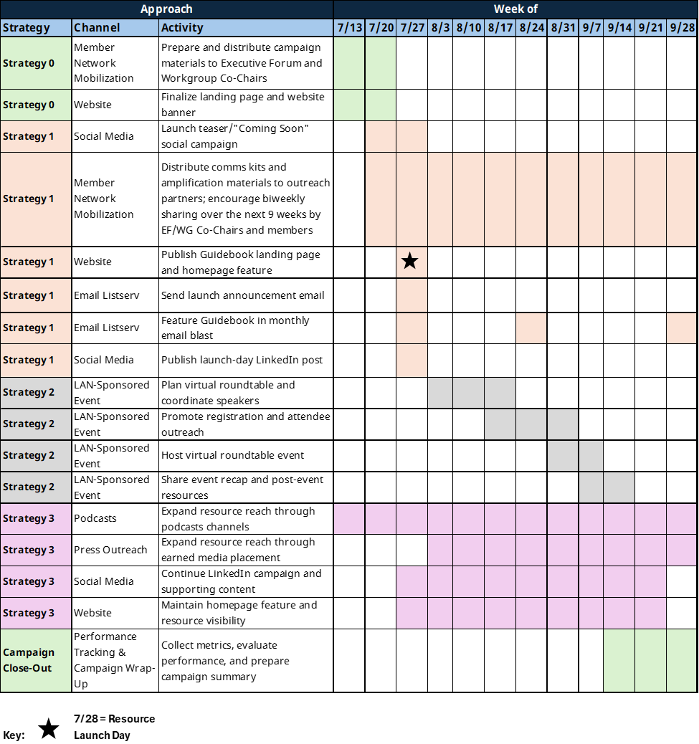

Risks, Dependencies, and Contingencies
Should podcast invitations or earned media opportunities not materialize within the campaign window, the LAN Operator Team will repurpose developed assets through owned and partner channels to maximize value and maintain campaign momentum.
Potential contingency activities may include:
- Publish thought leadership articles on the LAN Website
- Convert podcast talking points into a blog or Q&A article
- Develop additional LinkedIn carousel posts using podcast content
- Feature SMEs in the monthly newsletter
- Expand member Network Mobilization with additional sharing opportunities
- Repurpose webinar recordings into short video clips
If the anticipated launch date for the Guidebook is extended beyond July 28, we will adjust the campaign schedule accordingly.

Appendix

Resource Background Information
The LAN Patient Empowerment Guidebook: Pathways to Advancing Patient Empowerment is a practical, action-oriented resource developed by the LAN Patient Empowerment Workgroup to help a broad range of health care stakeholders — including providers, accountable care organizations (ACOs), health plans, employers, and community-based organizations — design, implement, and scale strategies that position patients as the primary drivers of their own care.
The Guidebook addresses an important gap in the field. While evidence shows that patients who play an active role in their health are more likely to make informed decisions, follow through on care, and sustain healthy behaviors over time, many organizations lack clear, actionable guidance on how to operationalize these approaches at scale.
To advance the three core pillars of patient empowerment — affordability, access, and navigation — the Guidebook presents three key levers: (1) redesigning financial incentives, (2) increasing access to wellness activities, and (3) delivering personalized reminders and nudges. For each lever, it outlines stakeholder-specific actions, real-world bright spots, change management considerations, and a patient profile that illustrates how these strategies can be applied across the care journey.
The Guidebook also highlights relevant CMS Innovation Models that support patient empowerment and identifies key policy and regulatory barriers organizations may encounter when implementing these strategies.

Podcast Recommendation Details
Table 11. Podcast Recommendation Details
Podcast Name* | Relative Value to the LAN
The ACO Show | - Description - Podcast focused directly on accountable care organizations, population health, payment reform, and value-based care  - Primary Topics Discussed - Accountable Care, value-based care  - Rationale – Supports LAN leadership discussing alternative payment models (APMs), accountable care, population health, and health care transformation. Direct alignment with HCPLAN mission and stakeholder audiences  - Recommended Audience – Direct alignment with LAN mission and core stakeholder audiences
Creating a New Healthcare | - Description - Healthcare transformation podcast covering prevention, care redesign, value-based care, and system innovation  - Primary Topics Discussed - Healthcare transformation, value-based care  - Rationale - Strong alignment with HCPLAN priorities and executive stakeholder audiences  - Recommended Audience - Strong fit with patient empowerment and health care transformation themes
Relentless Health Value | - Description - Podcast focused on improving patient outcomes while tackling and recommending solutions to fraud, waste, and abuse (FWA) within the U.S. healthcare system  - Primary Topics Discussed – FWA, price transparency, patient empowerment/engagement  - Rationale – Strong alignment with value-based care, payment reform, and health care executive audiences  - Recommended Audience - For relevant initiatives - better fit for prevention, patient engagement, and operational transformation topics
20-Minute Health Talk | - Description - Health system podcast discussing care delivery, patient engagement, innovation, and public health topics  - Primary Topics Discussed - Care delivery, public health  - Rationale – Supports LAN initiatives tied to prevention, patient engagement, or operational improvement  - Recommended Audience - Strong fit for prevention and patient engagement topics

