Health Care Payment Learning & Action Network (HCPLAN.ORG)
7/20/2026

Patient Empowerment Guidebook Communications Kit

Request for Executive Forum Members and Workgroup Co-Chairs
Thank you for your leadership and support of the HCPLAN Patient Empowerment Workgroup. As part of the launch of the Patient Empowerment Guidebook, we invite you to help expand awareness of this new resource by sharing it with your professional network.
This communications kit includes suggested messaging and graphics designed to make participation easy while maintaining consistent campaign messaging. Please feel free to personalize the content to reflect your own voice and experience. Your support will help extend the Guidebook's reach and encourage broader adoption of its practical strategies for advancing patient empowerment.

Campaign Overview
The Patient Empowerment Guidebook campaign is designed to increase awareness, encourage engagement, and promote adoption of the Guidebook across the health care ecosystem. Executive Forum members and Patient Empowerment Workgroup members play an important role in expanding the campaign's reach by sharing the resource with their professional networks. This toolkit provides messaging and resources to make participation quick and easy while maintaining consistent campaign messaging.

Guidance
- Recommended posting window: July 28th – September 30th
  - Please feel free to post as often as you would like during this window; however, we encourage posting biweekly.
- Preferred platform: LinkedIn
- Please tag the HCPLAN LinkedIn page within your post
- Personalize the suggested language to reflect your own voice and experience.
- Include the Guidebook link whenever possible.
- Use the provided graphics whenever available to improve engagement.

Suggested LinkedIn Posting Schedule and Copy

Executive Forum Members
Designed For | Timing | Post Purpose | Copy | Visual
Executive Forum Members | Launch Week  (July 28) | Introduce the Guidebook | Patient empowerment is central to advancing value-based care. The new HCPLAN Patient Empowerment Guidebook offers practical guidance for providers, ACOs, health plans, employers, and community-based organizations working to make care more affordable, easier to access, and easier to navigate.  Explore the Guidebook here: [LINK]  #PatientEmpowerment | 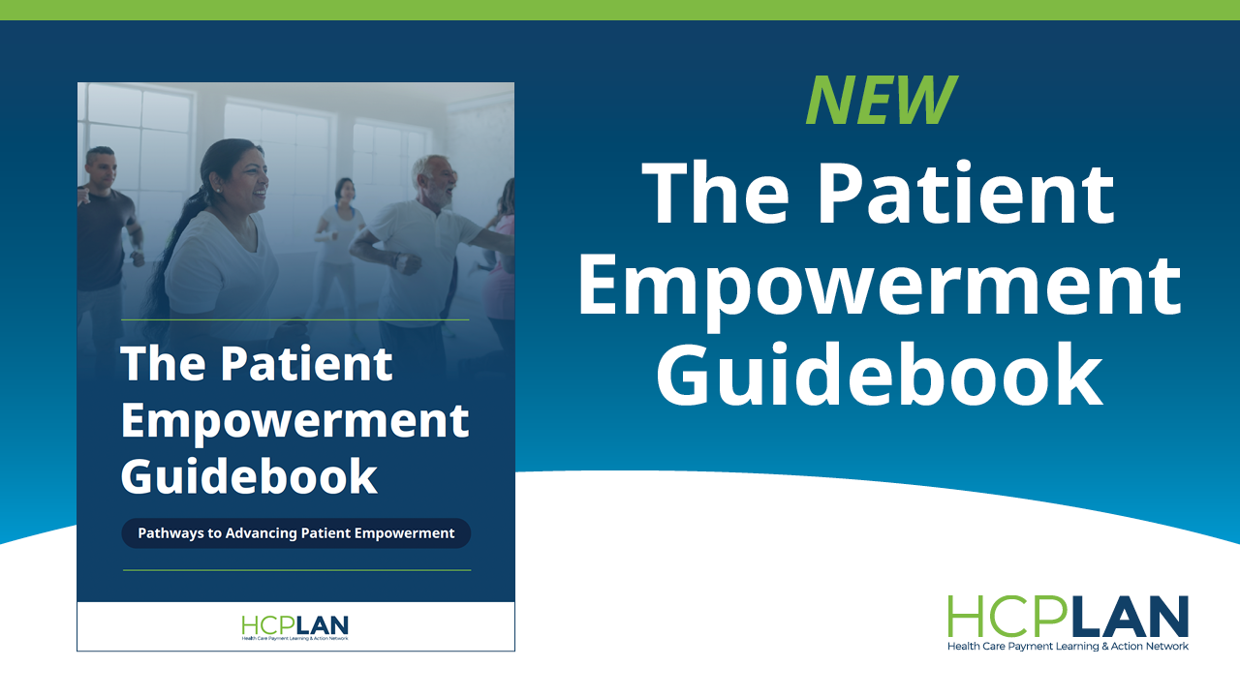
Executive Forum Members | August | Why patient empowerment matters | When individuals take an active role in their health, they are more likely to make informed decisions, follow through on care, and maintain healthy behaviors over time.  The HCPLAN Patient Empowerment Guidebook offers practical guidance to help organizations design, implement, and scale patient empowerment strategies that support better care and better results.  Learn more here: [LINK]  #PatientEmpowerment | 
Executive Forum Members | August | Focus on affordability, access, and navigation | The HCPLAN Patient Empowerment Guidebook is organized around three interconnected principles: making care affordable, ensuring patients can access the services they need, and helping them navigate the health care system with confidence.  These principles offer a practical starting point for organizations looking to support patients in ways that are easier to understand and act on.  Read the Guidebook here: [LINK]  #PatientEmpowerment | 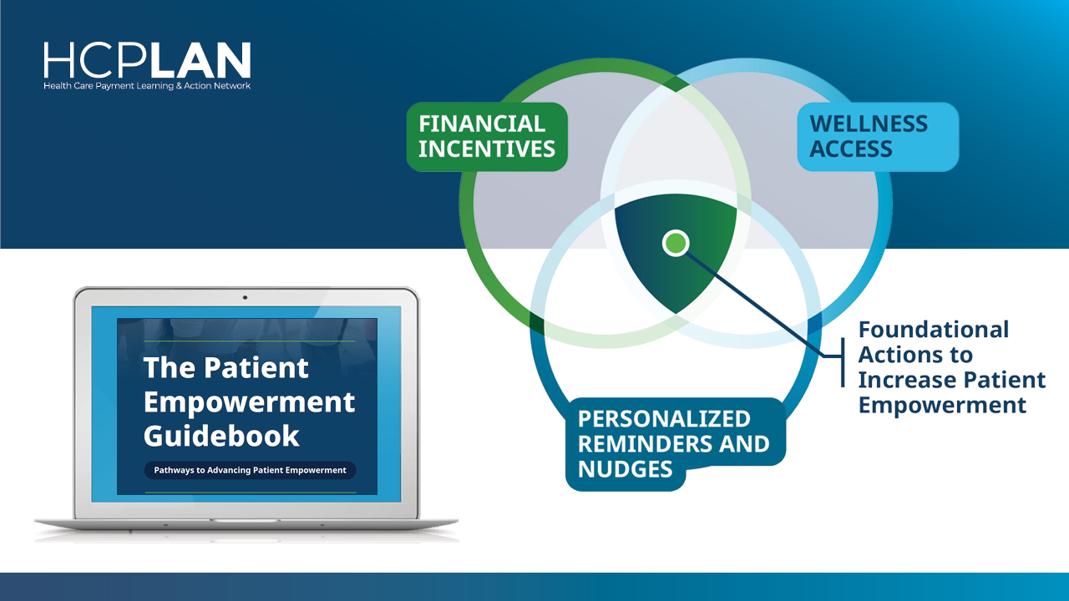
Executive Forum Members | September | Patient empowerment is not one-size-fits-all | Patient empowerment is not one-size-fits-all. Patients may lead decisions, share decisions, or rely more on trusted care partners depending on their goals, readiness, health literacy, language, and digital access.  The HCPLAN Patient Empowerment Guidebook explores ways organizations can support patients in ways that fit their needs and circumstances.  View the full resource here: [LINK]  #PatientEmpowerment | 
Executive Forum Members | September | Spotlight practical strategies | Patient empowerment becomes more actionable when organizations can see concrete strategies they might adapt. The HCPLAN Patient Empowerment Guidebook includes examples such as redesigning financial incentives to improve affordability, expanding access to wellness activities, and using personalized reminders and nudges to strengthen navigation.  Access the Guidebook here: [LINK]  #PatientEmpowerment | 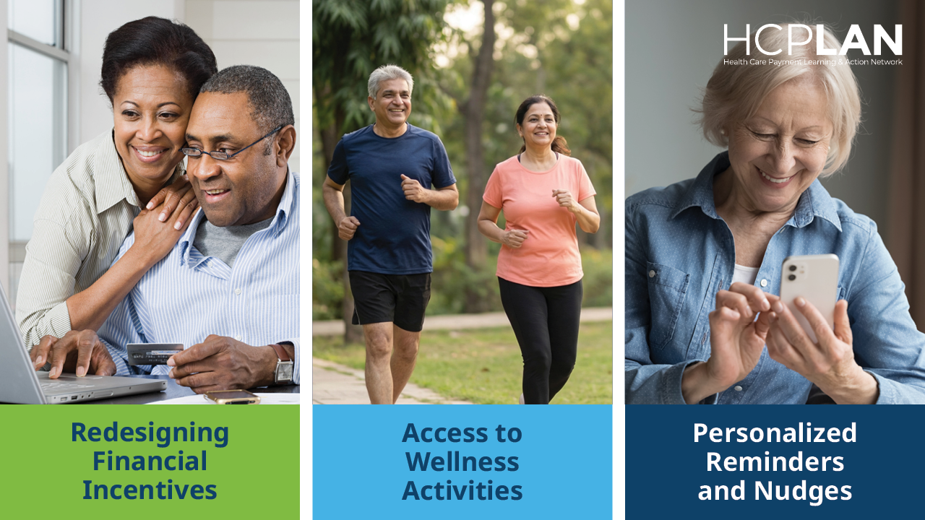

Patient Empowerment Workgroup Co-Chairs
Designed For | Timing | Post Purpose | Copy | Visual
Patient Empowerment Workgroup Co-Chairs | Launch Week  (July 28) | Introduce the Guidebook and Workgroup role | I’m excited to share the HCPLAN Patient Empowerment Guidebook, a practical resource for organizations looking to help patients take a more active role in their care.  As a Co-Chair of the Patient Empowerment Workgroup, I’m grateful to the members who contributed their perspectives and experience to this effort. The Guidebook focuses on affordability, access, and navigation.  Check out the full Guidebook here: [LINK]  #PatientEmpowerment | 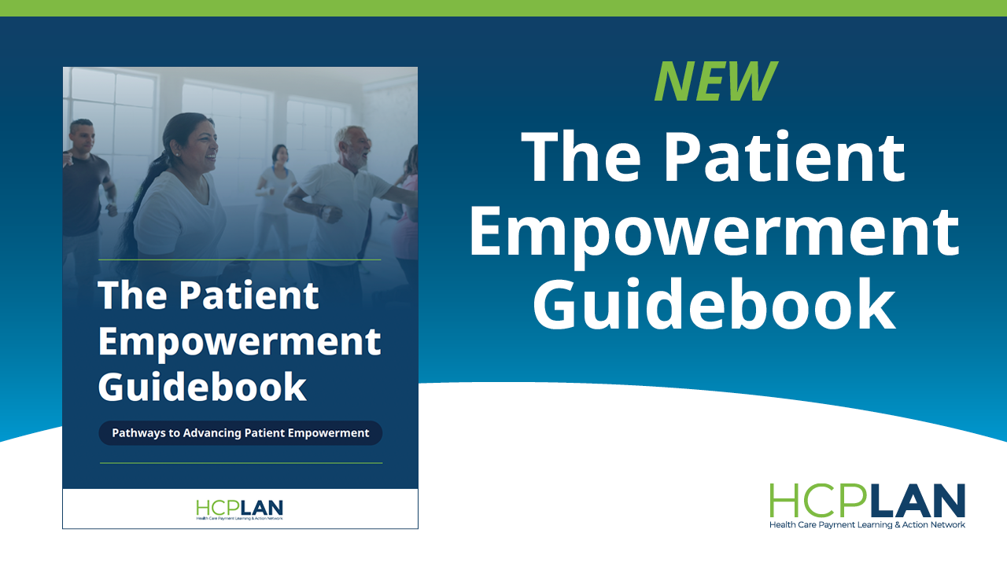
Patient Empowerment Workgroup Co-Chairs | August | Highlight practical strategies | What does it take to help patients play a more active role in their care? The HCPLAN Patient Empowerment Guidebook offers practical strategies across affordability, access, and navigation, including examples like expanding access to wellness activities and using personalized reminders and nudges to help patients navigate care.  Learn more here: [LINK]  #PatientEmpowerment | 
Patient Empowerment Workgroup Co-Chairs | August | Connect patient empowerment to value-based care | Many organizations want to advance patient empowerment but need clearer guidance on how to design, implement, and scale related strategies.  As a Patient Empowerment Workgroup Co-Chair, I’m pleased to share a resource that connects patient empowerment to value-based care through practical approaches focused on affordability, access, and navigation.  Learn more here: [LINK]  #PatientEmpowerment | 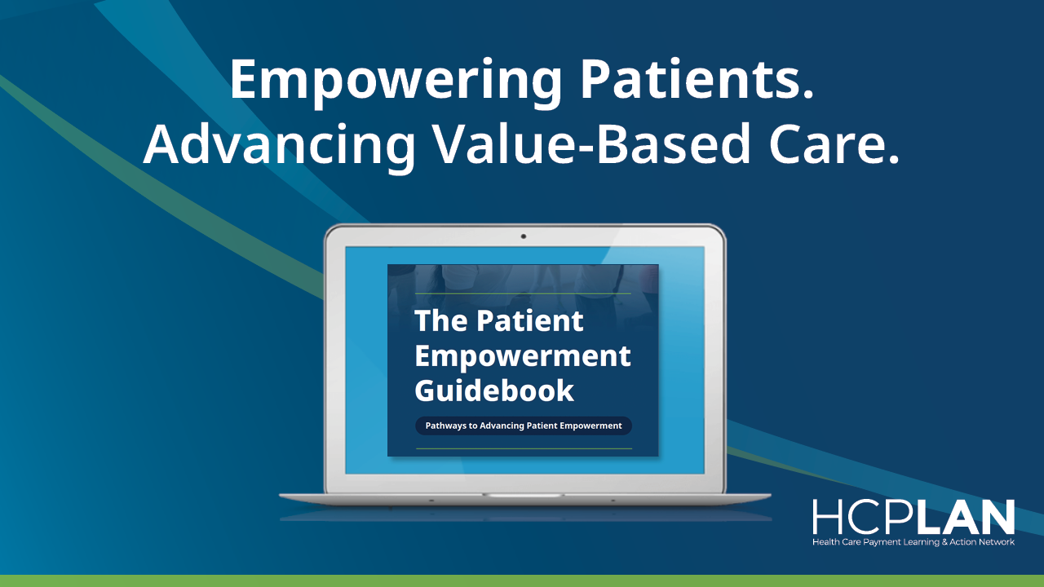
Patient Empowerment Workgroup Co-Chairs | September | Patient empowerment is not one-size-fits-all | Patient empowerment should not rely on a one-size-fits-all model. Patients may lead, share, or delegate decisions depending on their goals, readiness, health literacy, language, digital access, and support from trusted care partners.  The HCPLAN Patient Empowerment Guidebook offers ideas organizations can adapt to support patients in ways that fit their needs and circumstances.  Read the Guidebook here: [LINK]  #PatientEmpowerment
Patient Empowerment Workgroup Co-Chairs | September | Encourage patient journey support | Patients often need support finding resources, understanding complex medical information, and navigating the care process. The HCPLAN Patient Empowerment Guidebook helps organizations consider how to provide information, support, confidence, and connections throughout the care journey.  I hope this resource helps continue the conversation around patient empowerment and its role in advancing value-based care.  Explore the full Guidebook: [LINK]  #PatientEmpowerment | 

Patient Empowerment Workgroup Members
Designed For | Timing | Post Purpose | Copy | Visual
Patient Empowerment Workgroup Members | Launch Week  (July 28) | Introduce the Guidebook | Patient empowerment goes beyond engagement. It means helping people feel informed, supported, and able to take an active role in their care.  I’m proud to have contributed to the HCPLAN Patient Empowerment Guidebook, which highlights practical approaches across affordability, access, and navigation for organizations across the health care ecosystem.  Take a look at the Guidebook here: [LINK]  #PatientEmpowerment
Patient Empowerment Workgroup Members | August | Patient empowerment focus | What does patient empowerment look like in practice? The HCPLAN Patient Empowerment Guidebook includes strategies organizations can consider, including redesigning financial incentives to improve affordability and using personalized reminders and nudges to strengthen navigation.  Want to learn more? [LINK]  #PatientEmpowerment
Patient Empowerment Workgroup Members | August | Highlight affordability, access, and navigation | Helping patients take an active role in their care requires practical strategies and a clear understanding of where organizations can make a difference.  I’m proud to have helped shape the HCPLAN Patient Empowerment Guidebook, which focuses on three connected areas: making care more affordable, helping patients access needed services, and supporting people as they navigate the health care system.  Read more here: [LINK]  #PatientEmpowerment
Patient Empowerment Workgroup Members | September | Patient empowerment is not one-size-fits-all | Empowerment will not look the same for every patient. Patients may lead, share, or delegate decisions depending on their goals, readiness, health literacy, language, digital access, and trusted supports.  The HCPLAN Patient Empowerment Guidebook offers practical ideas organizations can adapt to support patients in ways that fit their needs and circumstances.  Ready to explore it? [LINK]  #PatientEmpowerment
Patient Empowerment Workgroup Members | September | Encourage patient journey support | Patients often need support finding resources, understanding complex medical information, and moving through the care process. The HCPLAN Patient Empowerment Guidebook describes an ideal experience where patients have the information, support, confidence, and connections they need to make decisions, act, and stay engaged in ways that fit their goals, preferences, and daily lives.  Explore the resource here: [LINK]  #PatientEmpowerment

